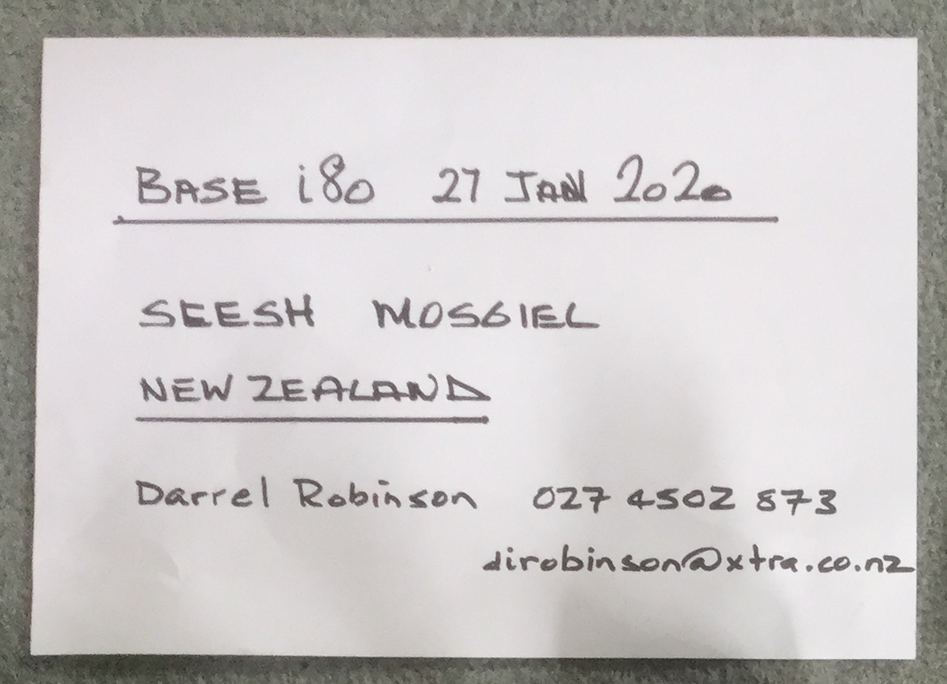

Base i80 27 January 2020

Satellite Survey Equipment Sales and Hire

DUNEDIN

Darrel Robinson

027 450 2573

dirobinson@xtra.co.nz

Rover i80 27 January 2020

Satellite Survey Equipment Sales and Hire

DUNEDIN

Darrel Robinson

027 450 2573

dirobinson@xtra.co.nz

